"European integration and the ESM"

20/09/2017

|

Speeches and presentations

ESM

Paris, France

[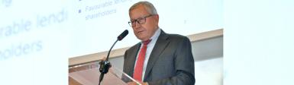](https://www.esm.europa.eu/sites/default/files/klaussciencesposlider-ps2.jpg)

   
   
   
 

**Klaus Regling, ESM Managing Director  
"European integration and the ESM"  
Speech at Sciences Po, Paris School of International Affairs and School of Public Affairs**  
Paris, 20 September 2017  
(Please check against delivery)

Ladies and gentlemen,

It is a real pleasure for me to address you here in Paris, at such a reputable institution as yours. I have been working on European integration and international finance for most of my career. And so, Paris is an important city for me. It is here that the first step towards the European Union was taken, when six countries signed the treaty establishing the European Coal and Steel Community, in 1951. That moment also started the French-German twin engine that has driven so much of the European integration process. As a German citizen with a French audience, I wanted to remind you of that.

It was the French foreign minister Robert Schuman who first proposed that France and Germany put the production of coal and steel under a Common High Authority. It was a daunting idea at the time. It meant that each country would yield part of its sovereignty to a supranational institution. But it worked, and lead to the establishment of the largest single market in the world, and later to the euro. This has brought immense economic benefits to the citizens of Europe in the forms of jobs, stability, and higher living standards. At the same time, Europe’s social model has room for far more solidarity than is the case on all other continents.

Some of you may know that Schuman was born and bred in Luxembourg, and that he only became French later. My reason for this detour to Luxembourg, is - of course - that the European Stability Mechanism, the institution that I manage, is based there.

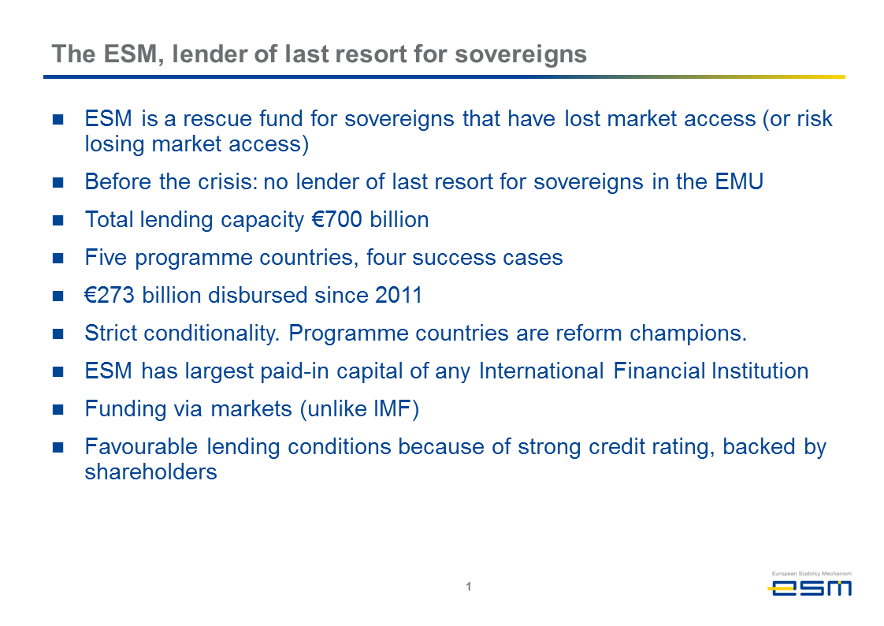

The ESM is a recent addition to the institutional bodies of the monetary union. Its role is to provide financial assistance to euro area countries that lose access to financial markets during a crisis.

We are, in other words, the lender of last resort for sovereigns. Such an institution did not exist in the monetary union before the crisis. When the Maastricht Treaty was signed, people thought it was impossible for a country to lose market access once it had entered the monetary union.

But this is precisely what happened between 2010 and 2012. As a consequence, there was a real risk that countries such as Greece, Ireland or Portugal could have been forced to leave the euro area. And this would have changed the European landscape significantly. To prevent this from happening, the euro area countries set up a fund for emergency loans at the height of the crisis in 2010. Initially this was a temporary institution, the European Financial Stability Facility. This was then replaced by the ESM as a permanent institution in 2012. The ESM was set up through a treaty between governments. Its shareholders are the 19 euro area countries. Together, the two institutions have a lending capacity of €700 billion.

In their short history, the EFSF and ESM have provided loans to five countries: Greece, Ireland, Portugal, Spain and Cyprus. In total, we have disbursed €270 billion in loans, 2.5 times as much as the IMF globally in the same time period. The ESM has a paid-in capital of €80 billion, which is the highest of any international financial institution. But we do not use this money to lend money to programme countries. It functions as a safeguard to our investors. The ESM does not spend any taxpayer money to finance its assistance programmes.

Instead, we raise the money that we need from investors by issuing bonds and bills. We can borrow at very favourable rates. This is because of our high credit rating, which is due to the high paid-in capital of the ESM. Our low rates mean considerable budget savings for programme countries, because the interest payments they make to the ESM are the same as those we pay in the market to countries that borrow large amounts. In fact, our lending rates are only a third of what the IMF charges. In the case of Greece, this saves the country almost €10 billion per year, or 5.6 percent of its GDP. These are very substantial amounts, and are a form of financial solidarity between euro area countries that few people realize exists.

In order to qualify for such advantageous loans, countries must commit to strict economic reform programmes. They need to fix the problems that led to the crisis. Usually, this means fiscal consolidation to reduce public deficits. Countries also need to restore competitiveness, which means putting an end to unsustainable wage policies, and bringing down nominal unit labour costs. Other reforms are aimed at liberalising labour and product markets. And lastly, there are also often problems in the banking sector that need fixing. The IMF has successfully applied this cash-for-reform or conditionality approach for decades.

Needless to say, such reforms are often painful for the people in a country in the beginning. Lowering pensions and wages, and cutting government support programmes are never popular, and that is understandable. But in the long run, the citizens in the countries will enjoy stronger economic results. Of the five ESM programme countries, four are success stories. Ireland, Spain, Portugal and Cyprus have ended their programmes, and their economies are doing well. Ireland’s economy grew by 5 percent last year and Spain by 3 percent. This makes them the growth champions of the euro area. All programme countries have also done extremely well in modernizing their economies, according the World Bank and the OECD. They are reform champions, and the structural changes they have made to their economies forms the basis for futures successes.

Greece is the only country that is still in an ESM active programme, of which it has entered the third and final year. The government is on the right track to implement the reforms that it has promised. If it continues to make these changes, chances are good that it can regularly refinance itself after completing the programme. Already, Greece made a first step in that direction in July, when it issued its first bond since 2014. Euro area governments have promised that they stand ready to provide further debt relief to the country if it continues to implement the reforms, and successfully exits the programme next year. And, of course, only if it still needed.

The ESM is not the only innovation that came out of the euro debt crisis. A number of other steps were taken to make the monetary union more robust, and to make its economy more resilient. Firstly this was because the countries that lost market access did their homework. The fact that macroeconomic imbalances have been reduced in many countries is due in large part to national policies. Budget deficits have clearly decreased everywhere. Competition has been restored through lowering nominal wages and salaries – what economists call “internal devaluations” – and through structural reforms, particularly in programme countries.

Secondly, the fiscal rules for the European Union were considerably tightened, and the Commission was given new powers to monitor and sanction budget offenders. Economic surveillance was broadened with the new “Macroeconomic Imbalances Procedure”.

And finally on the financial side, important progress was made in setting up the Banking Union. With the Single Supervisory Mechanism, Europe now has a central supervisor for the 130 largest banks, while the Single Resolution Board is a cross-border authority to resolve banks. It is worth underscoring that this constitutes a significant transfer of national competences to the European level. Such steps would have been unthinkable only a few years ago.

In short, Europe came up with a comprehensive policy response to the crisis. As a result, Europe is now stronger than it was before the crisis. Not only institutionally, but also economically. Let me give you some evidence of that.

The economic recovery that started in 2015 has become stronger recently. Euro area growth came in above that of the U.S. last year. Confidence among consumers and businesses is at the highest level since the start of the crisis. The recovery is also well-synchronized, with each euro area country posting positive growth.

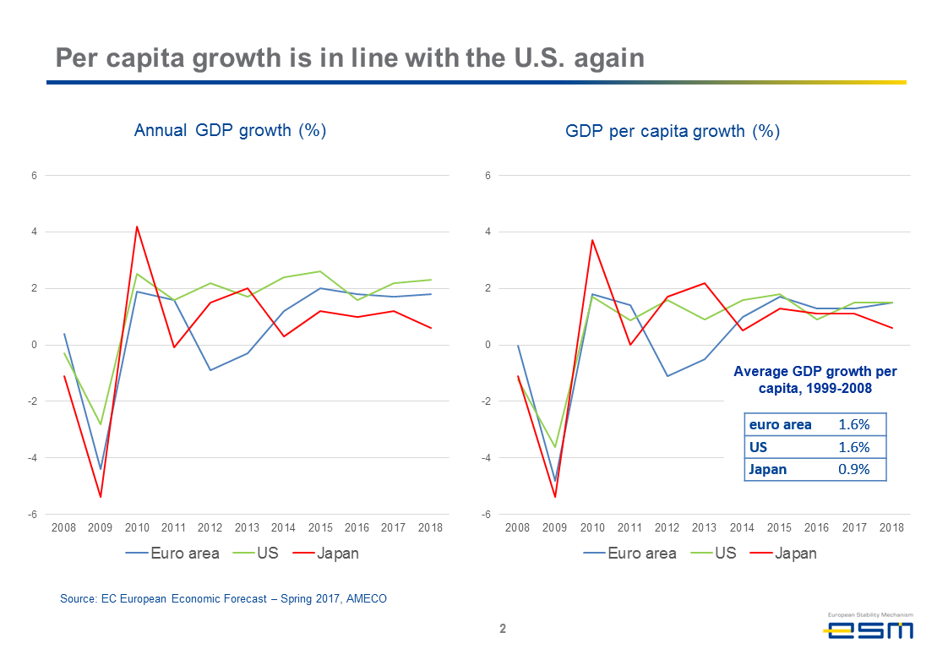

A point that is often forgotten is that Europe’s capacity to create wealth for its citizens is as great as that in the U.S. This can be seen from per-capita growth, which is back in line again with that in the United States. This was always the case in the decades before the crisis, but the relationship was disrupted during the crisis. Europe’s headline growth rate is lower, but that is because we have lower population growth, because of lower birth rates and less immigration than in America.

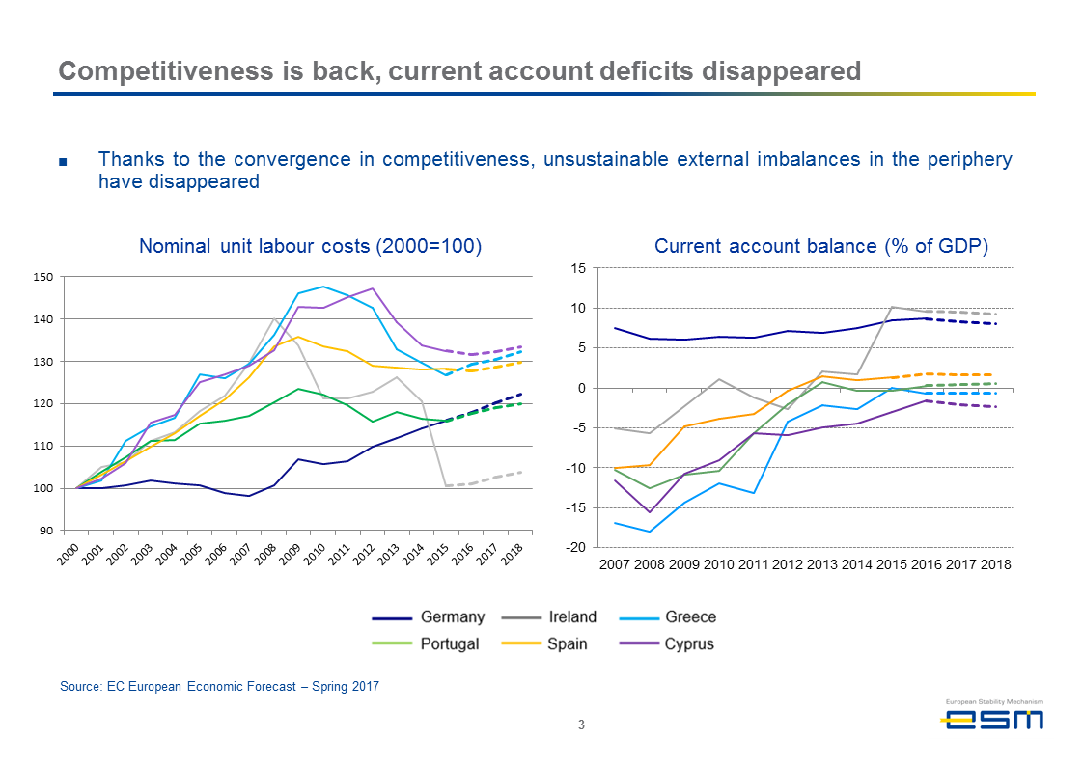

Macroeconomic imbalances, which were a central reason for the euro crisis, have now been sharply reduced. Competitiveness has returned in many euro area countries, as nominal unit labour costs converged to more sustainable levels. Former programme countries in particular have made good progress in this area, often after years of excessive wage increases. As a result, the unsustainably high current account deficits from before the crisis have disappeared. To prevent such imbalances from building up in the future, Europe has put in place the Macroeconomic Imbalances Procedure.

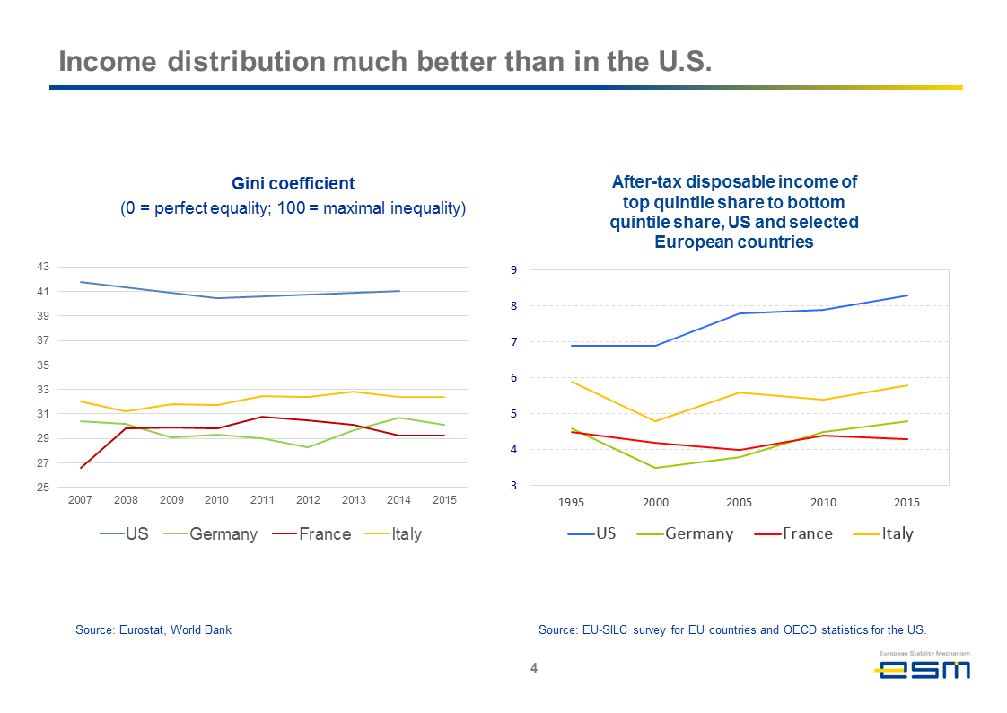

Another strong point of the European economy is much better income distribution than in the rest of the world. This can for instance be measured by the GINI coefficient which ranges from 0 to 100, with the lower bound expressing perfect equality. In the U.S., it stands at 41, and in France and Germany around 30. Income equality continued to deteriorate in the U.S – and China – during the last decade but remained broadly stable in Europe. It is true that rising inequality is a problem throughout Western societies, but Europe’s starting position is far better. Our social model, with a strong safety net for those who need it, is superior in dealing with negative side-effects of globalisation. It should also help to keep populism in check.

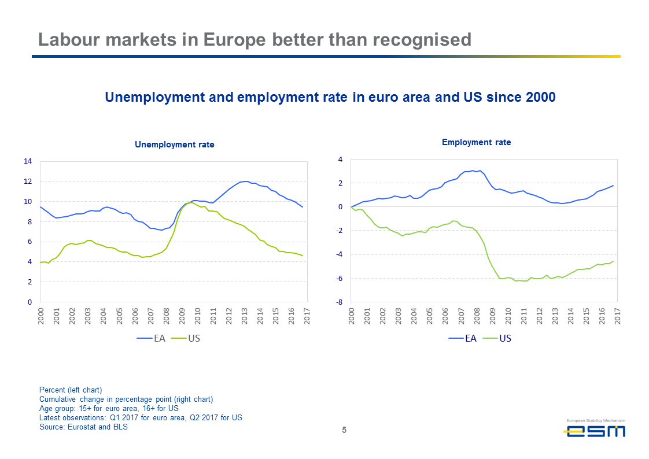

In labour markets, high unemployment remains a problem, particularly in countries such as Italy and Spain. It is a pressing issue for too many young people. What does not get enough attention to my mind however, is that the employment rate in Europe is higher today than in 2000, which means that a higher share of the population actually has a job than 16 years ago, despite the high unemployment rate. In America, the employment rate has dropped by more than 4 percentage points in that period.

Not everything is well, of course. Europe does need to address its low potential output growth rate. With our poor demographics, growth will mainly come from productivity gains. Structural reforms need to continue in all countries, not just in those who received an ESM assistance programme. Europe needs to further increase the participation rate of women into the labour force, and raise the mandatory and effective retirement age for everybody. Stronger investment would also help potential output growth.

In this context, countries should make every effort to integrate immigrants into the work force. Politically, this can be a thorny issue. Yet without immigration, the population of countries such as Germany and Austria would already be shrinking.

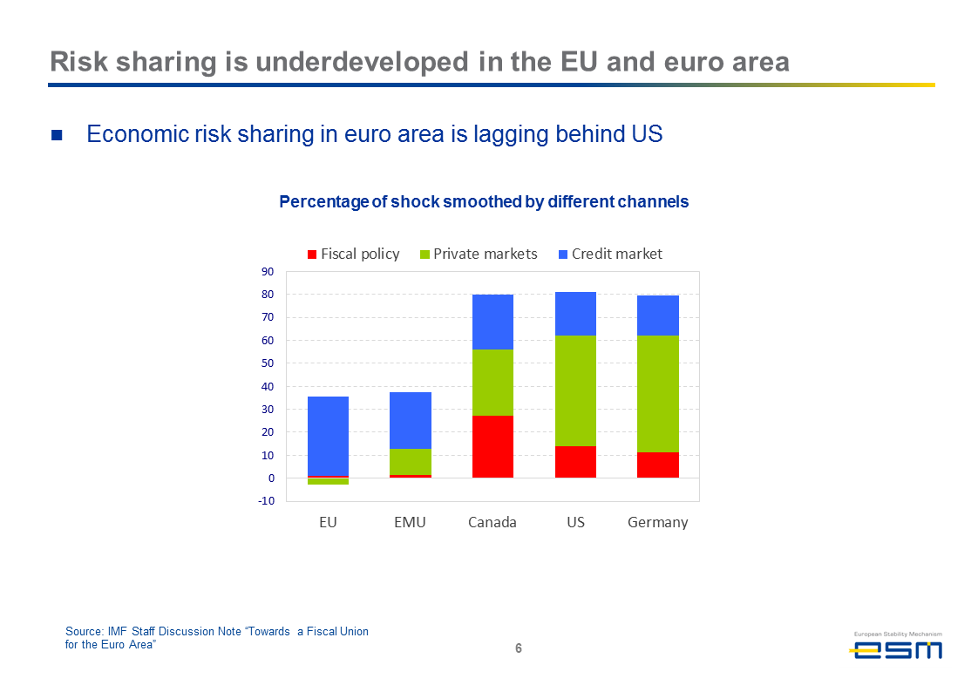

Another area where the euro area needs to do better is economic risk-sharing. Risk sharing is the sum of mechanisms through which a shock – positive or negative – to one country’s economy is shared by others. This helps smooth business cycles and makes national economies more resilient, and thus the euro area as a whole. In the U.S., but also in countries such as Germany or France, economic risk-sharing is much higher than in the euro area. Risk sharing can take place both through fiscal means and through private markets. Both channels need to be widened in the euro area.

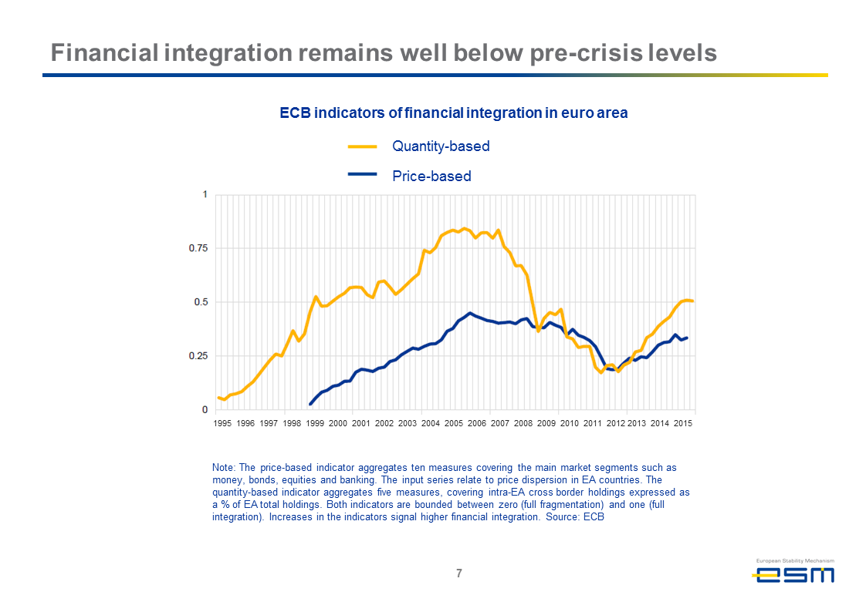

One of the reasons for poor economic risk-sharing is the decline in financial integration in the euro area during the crisis, when the home bias of market participants and of banks increased significantly. The data show that financial integration quickly rose after the euro was introduced, as one would expect. It then crashed during the crisis, and while it has recovered since then, it is still well below its peak. A likely explanation for that is that banks are still weighed down by non-performing loans that are a legacy of the crisis. I will say a bit more about this in a minute.

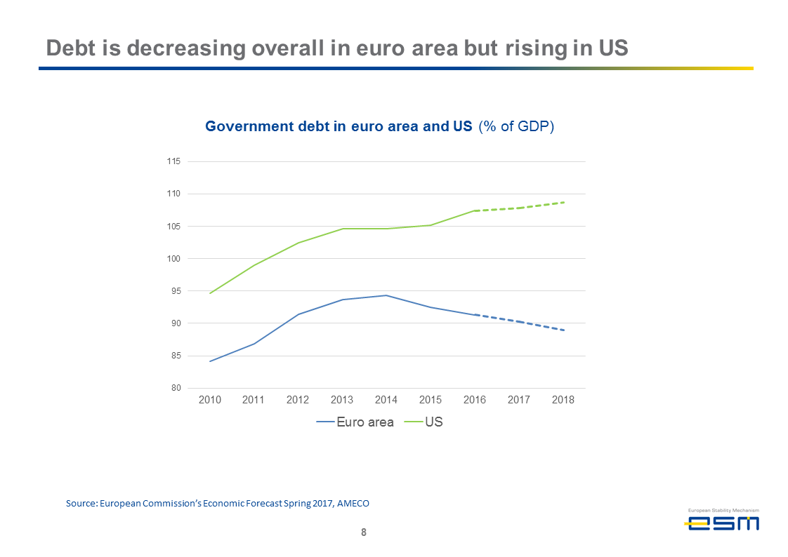

Now let me turn to the fiscal side of the economy. Here, the overall picture is favourable. Debt is decreasing. The euro area debt-to-GDP ratio stood at 91 percent last year, and is projected to continue to drop in the coming years.

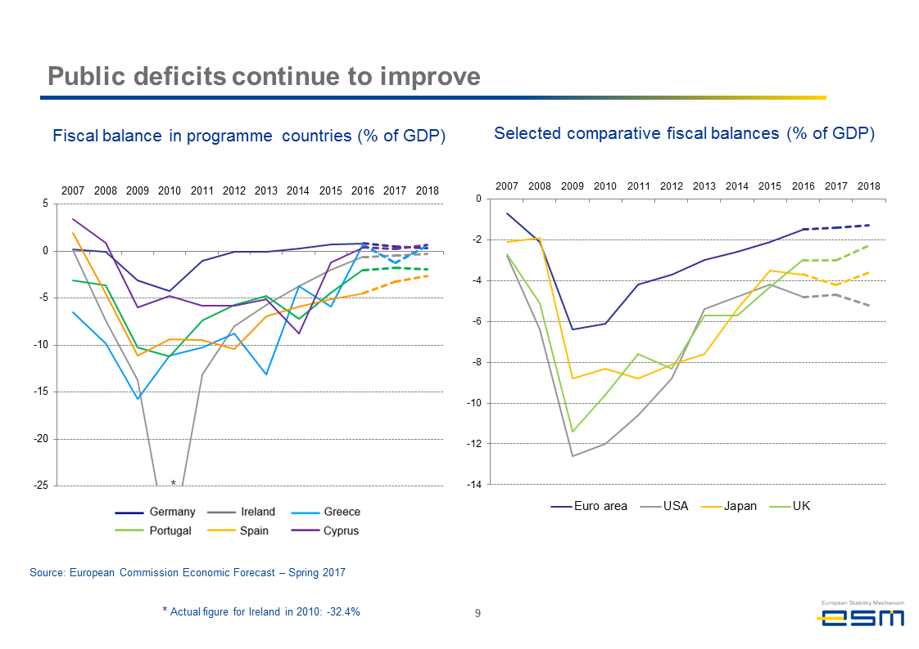

Public deficits have shrunk after the crisis, and converged to a narrow range. The aggregate fiscal deficit of the euro area is much better than that of the UK, the U.S., or Japan. Importantly, this gives the region more fiscal policy space than other large economies, if the next crisis hits. And - as I already mentioned when talking about Greece - high debt levels in former programme countries are helped by the ESM’s favourable lending terms.

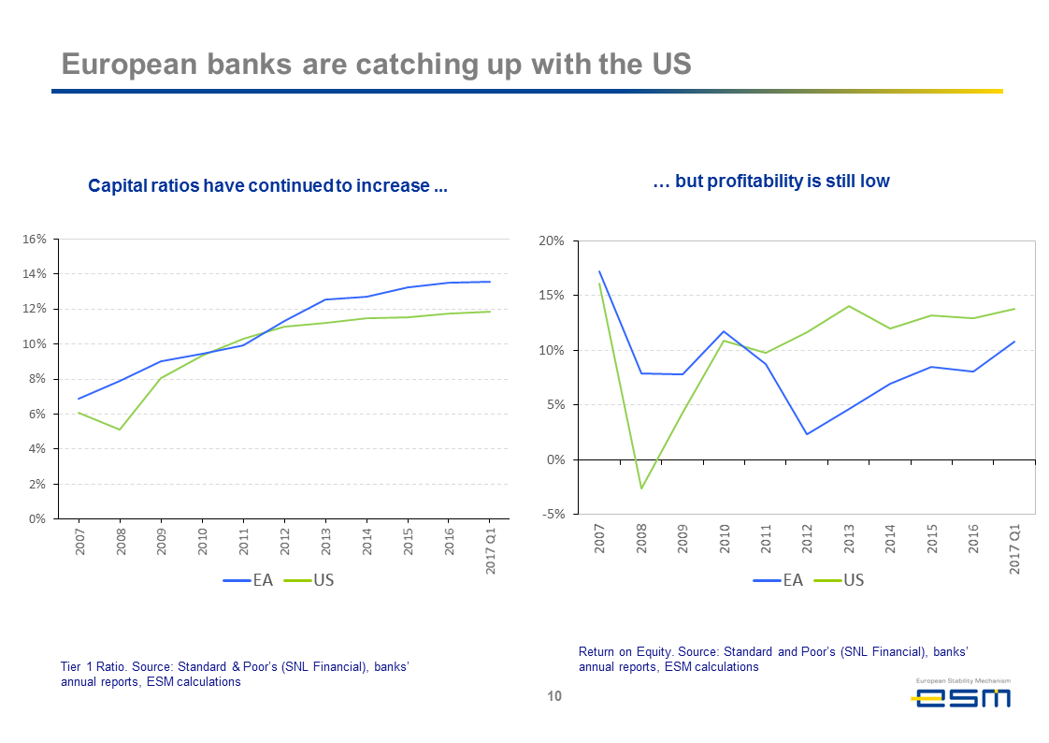

When looking at the financial sector, European banks have strongly recovered after the crisis, just like they did elsewhere in the world. The system is much safer now. Capital has doubled, and profitability is returning, though it is still below the levels in the U.S.

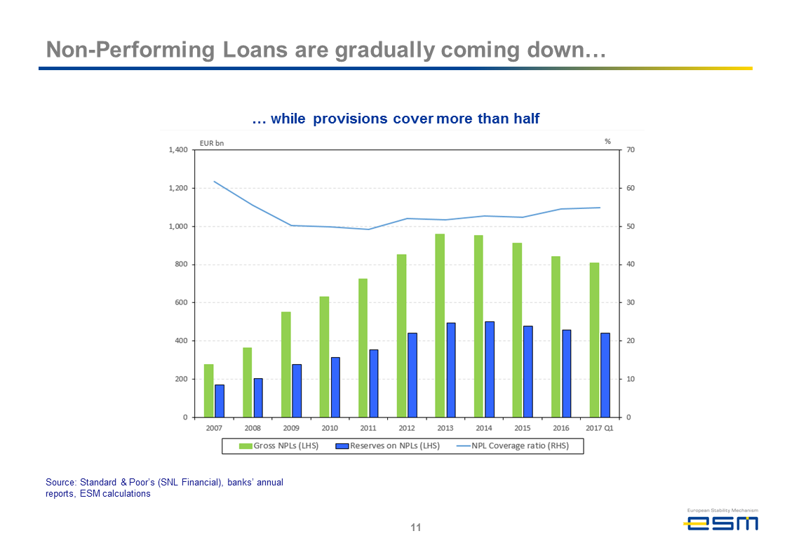

Non-performing loans have been gradually coming down from a peak in 2013, and are well-provisioned. Still, they are clearly too high, particularly in some countries. This means the financial sector is less efficient than could be the case. Managing non-performing loans not only eats up capital that could otherwise be used for providing granting loans, and boosting the economy. It also means that valuable management time is needed to manage these portfolios. Time that could otherwise be spent on developing the business model and, for instance, on strategic acquisitions, also across borders. There is room for consolidation in the financial sector in many countries in Europe. And so, NPLs are probably one of the important reasons why euro area financial integration remains low. As this in turn stands in the way of economic risk-sharing via financial and capital markets, it becomes clear why reducing non-performing loans is an urgent priority. In that light, it was important that European ministers adopted an action plan to deal with non-performing loans in July.

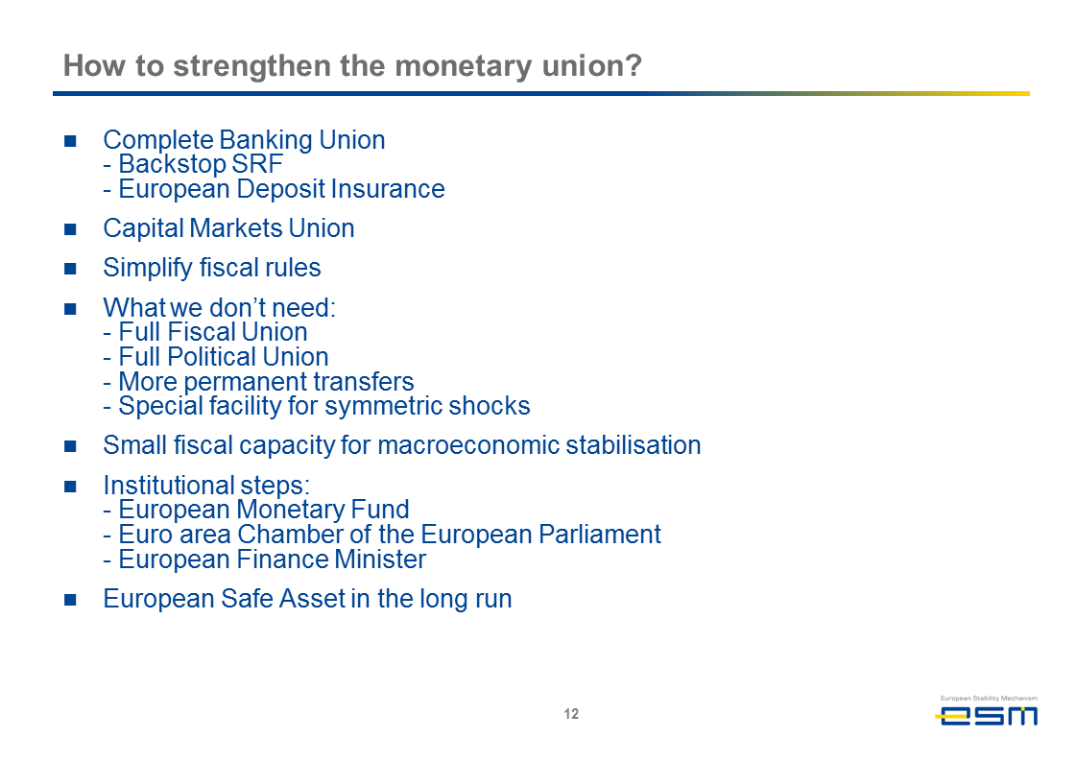

But despite all this good progress, the euro area still needs to take a number of further steps, to make monetary union more robust, and to further improve the resilience of the economy.

These steps must, of course, be seen against all the measures already taken during the last few years. Let me start by mentioning the things we do not need, in my view, to make monetary union work better. We do not need full fiscal union, nor a full political union for the proper functioning of monetary union. With full fiscal and political union, we would be the United States of Europe.

We also do not need additional transfers between countries. Transfers are important to promote real convergence. But the existing EU budget already allows for significant transfers from rich to poor countries, which can amount to up to 4 percent of a receiving country’s economy. The use of budgetary funds to promote real convergence could become more effective, but we do not need a completely new instrument, in my view. In addition, programme countries that received EFSF or ESM loans benefit from the cheap financing, which is equivalent to a transfer.

We also don’t need a large additional budget to counter deep symmetric crises. Europe has shown that in truly exceptional cases, we can successfully fight a crisis through a simultaneous increase in fiscal deficits, such as during the global financial crisis of 2008/09. An exception clause in the Stability and Growth Pact allows breaching the three percent deficit maximum in case of a severe crisis. Finally, the euro does not need a new investment budget. It already exists for the EU, in the form of the so-called Juncker Plan, the EIB, and the structural funds available through the EU budget. If needed, these facilities can be increased and their use could become more efficient.

I am also a proponent of a strict adherence to the subsidiarity principle. If certain things can be done better at the national or local level, we should leave them there, closer to the people, and not transfer them to the European level.

But certain further steps could be useful. First, Banking Union needs to be completed. In the wake of the crisis, the euro area established the first two pillars of Banking Union: the Single Supervisory Mechanism and the Single Resolution Board. What is needed now is a financial backstop for the Single Resolution Fund, to make it more credible in the eyes of financial markets. This is a role that the ESM could take on.

And Banking Union is not complete without its third pillar, a European Deposit Insurance Scheme. Work on that continues, but it will only happen after legacy issues at banks in a number of countries have been tackled first.

Secondly, the euro area should harmonize bankruptcy, tax and corporate law, a project known as Capital Markets Union. This would ease the way for cross-border equity investments and open up new ways of funding for companies. It would also reduce their heavy reliance on bank funding, one of the reasons that Europe’s banking sector is so large in comparison to the size of the economy. Finishing the Banking Union and setting up the Capital Markets Union would be a big help in increasing risk-sharing in the monetary union.

There is also now a political debate about simplifying the European Union fiscal rules. Initially laid out in the Maastricht Treaty and the Stability and Growth Pact, the rules have been tightened since the crisis. But they are now too complex, and often hard to understand. So I welcome the debate on how to make them more effective.

A limited euro area budget is also under discussion. It could serve different purposes. In my view, we have a real need in the monetary union to create a facility that deals with asymmetric economic shocks. A country hit by an asymmetric shock would receive money during a crisis, but would need to repay it once it recovers. The fund would therefore not lead to permanent transfers or debt mutualisation. Examples from the U.S. show that this is possible. Almost all states there have rainy day funds, which they fill during the good times, and which they can borrow from when a crisis hits. A rainy day fund for the euro area would have to be 1% to 2% of the economy, so between €100 and €200 billion. A complementary unemployment insurance, which also exists in most U.S. states, could be financed from a small fraction of existing employer and employee contributions, so that no extra financing is needed. This would enhance risk sharing.

A number of institutional developments are also under consideration. First, a permanent president of the Eurogroup could be useful, to better coordinate economic and financial policies and to represent the euro area in international bodies such as the G7 or the IMF. That person could become the euro area finance minister, once his or her competences have been clearly defined.

Secondly, the European Parliament could create a subgroup representing euro area countries. This would facilitate the accountability of all matters related to the euro area, which the Parliament now does not have a say in. However, national parliaments will continue to have a say over ESM lending, because the associated risk is assumed by national budgets.

Thirdly, there are thoughts about developing a European Monetary Fund. So far, the IMF has always contributed to the ESM rescue programmes in Europe, but a consensus is now growing that it will not play that same role again in a future crisis. The ESM could take over that role, as well as other tasks.

This list of ideas shows that cross-border cooperation in the euro area is very much alive. France elected President Emmanual Macron on an explicitly pro-European agenda this year. Elections in Germany are only days away. The expectation is that voters there too will confirm a pro-European stance.

This will provide a new impetus to the German-French twin engine that has driven European integration quite often during the last 65 years. I am confident it will continue to do so in the future, strengthening the European Union and the euro area.

Monetary union is not a goal in itself. Its aim is to bring more prosperity to Europeans: higher living standards, more stability, a fairer society and better chances for future generations.

Europe’s citizens have understood this very well. The popularity of the euro is at record levels. This vote of confidence is a mandate for policymakers to continue to work together.

Thank you for your attention.